💊
PharmaEZ
Pharmacy & Healthcare E-Commerce Application
MERN Stack — MongoDB · Express.js · React.js · Node.js

Project Name | PharmaEZ — Online Pharmacy & Healthcare Store
Technology Stack | MERN (MongoDB, Express.js, React.js, Node.js)
Domain | Pharmacy & Healthcare E-Commerce
Version | 1.0.0 • 2026
Document Type | Project Report & Technical Documentation

Developed using MERN Stack • Full Source Code Included

INTRODUCTION

PharmaEZ is your one-stop destination for effortless online healthcare and medicine shopping. With a user-friendly interface and a comprehensive product catalog spanning prescription medicines, over-the-counter drugs, vitamins, supplements, medical devices, baby care, and wellness products — finding the right healthcare item has never been easier.

Seamlessly navigate through detailed product descriptions, salt compositions, dosage forms, customer reviews, and available discounts to make informed healthcare decisions. Enjoy a secure checkout process, prescription upload and verification workflow, and receive instant order confirmation. For administrators, our robust dashboard provides efficient order management, inventory monitoring with low-stock alerts, prescription review tools, and insightful analytics.

Experience the future of online pharmacy with PharmaEZ today — where your health is our priority.

SCENARIO

Raj's Medication Refill Experience

Raj, a busy IT professional managing his elderly mother's healthcare, needs to refill her monthly prescriptions along with vitamins and a digital blood pressure monitor — all while juggling work deadlines. With no time to visit a physical pharmacy, he turns to PharmaEZ.

- Effortless Medicine Discovery: Raj searches for 'Metformin' and instantly sees results with generic name, salt composition, dosage form, and pack size. He filters by category and finds the exact brand prescribed.
- Prescription Upload: Since Metformin requires a prescription, PharmaEZ prompts Raj to upload a scanned copy. He uploads the PDF from his phone. The platform flags the order for pharmacist review.
- Seamless Multi-Product Cart: Raj adds Vitamin D3 supplements, Omega-3 softgels, and an Omron blood pressure monitor. The cart shows OTC vs. Rx items and calculates real-time pricing with discounts.
- Secure Checkout: With his saved delivery address and UPI payment, Raj checks out in under two minutes. Free delivery is applied (order above Rs.499) and GST is shown clearly.
- Order Confirmation & Tracking: Raj receives an order confirmation with unique number PEZ######. He tracks the status: placed > confirmed > processing > shipped > delivered from his dashboard.
- Admin / Pharmacist Workflow: The admin reviews Raj's prescription, verifies it, approves it, and marks the order confirmed. Stock is deducted automatically.
- Loyalty Rewards: After delivery, Raj notices 45 loyalty points credited — redeemable on his next order.

PharmaEZ proves to be the ideal solution for modern healthcare shopping — combining seamless product discovery, prescription compliance, secure payment, and reliable delivery all in one platform.

SYSTEM REQUIREMENTS

1. Software Requirements
These are the essential tools and platforms required to develop, test, and run PharmaEZ.

- Operating System: Windows 10/11, macOS, or Linux — cross-platform development and testing.
- Node.js (v18+): Runtime environment for both frontend build tools and backend server logic.
- npm (v8+): Package manager for installing React and Node.js dependencies.
- React.js (v18): JavaScript library for building dynamic, component-driven user interfaces.
- Vite: Lightning-fast build tool and dev server for the React frontend.
- Express.js: Lightweight web framework for building RESTful APIs on Node.js.
- MongoDB (v6+): NoSQL database for storing users, products, carts, orders, and prescriptions.
- Mongoose: ODM library for MongoDB — schema validation and query building.
- Browser: Google Chrome / Firefox (latest) — for rendering and testing the UI.
- Postman: Tool for testing REST API endpoints during development.
- Visual Studio Code: Code editor with built-in Git, terminal, and React extensions.
- Git & GitHub: Version control and collaborative development.

2. Hardware Requirements
- Processor: Intel Core i5 (8th Gen+) / AMD Ryzen 5 — fast compilation and multitasking.
- RAM: Minimum 8 GB (16 GB recommended) — for running dev servers, IDEs, and browsers.
- Storage: At least 2 GB free space — for packages, MongoDB, uploads, and project files.
- Display: 1366x768 or higher — optimal coding and layout visualization.

PROJECT ARCHITECTURE

TECHNICAL ARCHITECTURE
PharmaEZ follows the standard MERN stack architecture with a clear separation between frontend, backend, and database layers.

FRONTEND | BACKEND | DATABASE
• React.js 18  • React Router v6  • Context API (Auth+Cart)  • Axios HTTP Client  • React Icons  • React Hot Toast  • Vite Build Tool  • Custom CSS Variables | • Node.js v18+  • Express.js  • JWT Authentication  • bcryptjs (Hashing)  • Multer (File Upload)  • express-validator  • CORS Middleware  • RESTful API Design | • MongoDB v6  • Mongoose ODM  • User Collection  • Product Collection  • Cart Collection  • Order Collection  • AdminConfig Collection  • MongoDB Atlas / Local

ER DIAGRAM — Entity Relationships
The PharmaEZ ER diagram represents entities and relationships in the pharmacy e-commerce system.

Entity | Key Fields | Relationships
USER | name, email, password, phone, addresses[], prescriptions[], wishlist[], role, loyaltyPoints | Has many Orders Has one Cart Has many Prescriptions
PRODUCT | name, genericName, category, price, discountPrice, stock, prescriptionRequired, saltComposition, dosageForm, images[], reviews[] | Referenced in Cart Referenced in Orders Has many Reviews
CART | user (ref), items[{product, name, price, quantity}], discount | Belongs to one User References many Products
ORDER | user (ref), orderNumber, items[], shippingAddress, paymentMethod, totalPrice, orderStatus, prescriptionStatus, statusHistory[] | Belongs to one User Contains Products Has status history
ADMIN CONFIG | banners[], settings {freeShippingThreshold, taxRate, storeName} | Global store configuration

FEATURES

- Comprehensive Pharmacy Product Catalog: 10 healthcare categories — Prescription Medicines, OTC Medicines, Vitamins & Supplements, Personal Care, Medical Devices, Baby Care, Wellness, Healthcare Equipment, Ayurvedic & Herbal, COVID Essentials. Each product includes salt composition, dosage form, strength, pack size, usage instructions, and side effects.
- Prescription (Rx) Medicine Workflow: Rx products are clearly flagged. Customers must upload a valid prescription before checkout. The admin pharmacist reviews, approves, or rejects prescriptions through a dedicated dashboard panel.
- Advanced Search & Filtering: Full-text search across product name, generic name, and tags. Filters: category, price range, prescription requirement. Sort by price (low/high), top-rated, and newest.
- Shopping Cart & Wishlist: Real-time cart management with quantity controls and stock validation. Wishlist for saving products. Cart clearly differentiates OTC and Rx items.
- Multi-Step Secure Checkout: 3-step checkout: Address Selection > Payment Method > Order Review. Supports COD, UPI, Card, Net Banking, Wallet. Free shipping above Rs.499 and 5% GST calculated automatically.
- Order Management & Tracking: Auto-generated order numbers (PEZ######). Status progression: placed > confirmed > processing > shipped > delivered. Status history audit trail. Cancellation supported before shipment.
- Loyalty Points System: 1 loyalty point per Rs.10 spent. Points credited automatically after delivery and tracked in the user dashboard.
- Product Reviews & Ratings: 1-5 star ratings with comments. Aggregate rating recalculated on each new review submission.
- Admin Dashboard & Analytics: KPI cards (orders, revenue, users, products), 7-day revenue chart, order status breakdown, low-stock alerts, inventory management, and prescription review workflow.
- Prescription Upload & Verification: Users upload prescription image/PDF. Admin reviews, approves, or rejects with notes. Order status is linked to prescription approval.
- Inventory Management: Real-time stock tracking with automatic deduction on order and restoration on cancellation. Low-stock alerts (<=10 units). Out-of-stock products disable Add to Cart.
- Responsive UI Design: Mobile-first responsive design using CSS variables with a pharmacy-themed green palette. Works on desktop, tablet, and mobile.

ROLES AND RESPONSIBILITIES

USER
Registered customers who can browse products, manage cart and wishlist, upload prescriptions, place orders, track deliveries, write reviews, and manage their profile and delivery addresses.

ADMIN / PHARMACIST
Platform administrator with access to the full admin dashboard — product management, order processing, prescription verification, user management, and inventory monitoring.

PRODUCT
A collection of all healthcare products including prescription medicines, OTC drugs, vitamins, medical devices, and wellness products — each with pharmacy-specific medical metadata.

CART
Stores products added by each user (differentiated by user ID). Calculates subtotal, applies shipping rules (free above Rs.499), and computes 5% GST automatically.

ORDERS
Stores all orders placed. Each order has a unique auto-generated number, tracks status with a full history audit trail, and records prescription status for Rx items.

User Flow
- Users register with name, email, phone, and password.
- They log in and receive a JWT token for subsequent requests.
- They browse healthcare products by category or search term.
- OTC products go directly to cart; Rx products require a prescription upload.
- 3-step checkout: address > payment > review and confirm.
- Order confirmation received with unique order number.
- Order status tracked in real-time from the profile dashboard.
- Loyalty points credited automatically after delivery.

MVC PATTERN

The PharmaEZ backend follows the Model-View-Controller (MVC) architectural pattern — separating the application into three interconnected layers for modularity, maintainability, and scalability.

Model Layer (Data Layer)
Handles all data-related logic using Mongoose schemas. Models defined: User, Product, Cart, Order, AdminConfig.
- User Model: Registration data, addresses, prescriptions, wishlist, loyalty points. Includes bcryptjs password hashing pre-save hook.
- Product Model: All healthcare product data with medical fields and embedded reviews. Auto-calculates discountPercent.
- Cart Model: Cart items per user with virtual subtotal and totalItems computed fields.
- Order Model: Full order lifecycle with auto-generated order numbers and status history audit trail.
- AdminConfig Model: Single-document collection for global store settings, banners, and categories.

Controller Layer
Acts as intermediary between routes and models — validates input, calls model methods, returns JSON responses.
- authController.js: register, login, getProfile, updateProfile, changePassword, addAddress, deleteAddress, toggleWishlist, uploadPrescription
- productController.js: getProducts (filters/search/pagination), getProductById, getFeaturedProducts, createProduct, updateProduct, deleteProduct, addReview
- cartController.js: getCart, addToCart (stock validation), updateCartItem, removeFromCart, clearCart
- orderController.js: placeOrder (stock deduction + loyalty points), getMyOrders, getOrderById, cancelOrder, getAllOrders, updateOrderStatus, getDashboardStats
- adminController.js: getAllUsers, toggleUserStatus, getPrescriptions, updatePrescriptionStatus, getAdminConfig, updateAdminConfig, getInventoryReport

View Layer (Routing Layer)
In a REST API, the View is the routing layer — endpoints invoke the appropriate controller functions for each HTTP method.

Advantages of MVC in PharmaEZ
- Separation of Concerns: Each layer has a clearly defined responsibility, improving readability and maintainability.
- Scalability: New features added by creating new routes, controllers, and models without touching existing code.
- Reusability: Auth middleware, error handler, and model methods reused across the entire application.
- Testability: Each layer can be independently unit-tested.
- Collaboration-Friendly: Developers work simultaneously on frontend, backend, and database without conflicts.

PROJECT SETUP AND CONFIGURATION

Creating Project Folder
- Create a new folder named pharmaez.
- Inside, create two sub-folders: client (React frontend) and server (Node.js backend).
- Open the pharmaez folder in Visual Studio Code.

Client Setup — Installing React App
- Open the client folder in the VS Code integrated terminal.
- Run:
npm create vite@latest . -- --template react
- Select React from the framework options, and JavaScript as the variant.
- Install dependencies:
cd client && npm install
- Install additional required packages:
npm install axios react-router-dom react-hot-toast react-icons
- Start the dev server:
npm run dev

Server Setup — Node.js & Express
- Open the server folder in the terminal.
- Initialize npm:
npm init -y
- Install backend dependencies:
npm install express mongoose bcryptjs jsonwebtoken cors dotenv multer express-validator
- Install dev dependencies:
npm install --save-dev nodemon
- Create: index.js, and folders: models/, controllers/, routes/, middleware/, config/, utils/

BACKEND DEVELOPMENT

1. Setup Express Server
- Create index.js as the main entry point. Configure Express on port 8000.
- Connect to MongoDB using Mongoose via config/db.js.
- Mount all API routes under the /api prefix.
- Serve uploaded prescription and product image files statically from uploads/.

2. Database Configuration
- Set up MongoDB locally (MongoDB Compass) or via cloud (MongoDB Atlas).
- Store the connection string as MONGO_URI in the .env file.
- config/db.js establishes the Mongoose connection with error handling and process.exit on failure.

3. Create Express.js Server
- Configure middleware: express.json(), CORS with allowed origins, express.urlencoded().
- Serve the uploads/ directory as a static folder for images and prescription files.

4. Define API Routes
- authRoutes.js — register, login, profile CRUD, addresses, wishlist, prescription upload
- productRoutes.js — GET with full query filters, CRUD (admin), reviews
- cartRoutes.js — get, add, update quantity, remove item, clear cart
- orderRoutes.js — place, my orders, detail, cancel, admin all orders and stats
- adminRoutes.js — users, prescription review, config, inventory

5. Implement Data Models
- Define Mongoose schemas for User, Product, Cart, Order, AdminConfig.
- Pre-save hooks: password hashing (User), order number generation (Order), discount percent calculation (Product).
- Implement full CRUD operations within controllers for each model.

6. User Authentication
- JWT-based stateless authentication using jsonwebtoken.
- protect middleware verifies the Bearer token from the Authorization header.
- adminOnly middleware checks role === 'admin'.
- Passwords hashed with bcryptjs (10 salt rounds) via pre-save hook.

7. Handle Products, Prescriptions & Orders
- Product routes support paginated, filtered, sorted MongoDB queries.
- Prescription upload uses Multer (max 5MB, image/PDF) stored in uploads/.
- Order placement: validates stock, checks Rx status, deducts stock, awards loyalty points.
- Order cancellation: restores stock, pushes status entry to statusHistory[].

8. Admin Functionality
- All admin routes protected by protect + adminOnly middleware.
- Admin can create/update/delete products with Multer image handling.
- Admin can view all orders, filter by status, update status with history logging.
- Admin can activate/deactivate users and view inventory reports.

9. Error Handling
- Global errorHandler middleware catches all errors passed via next(error).
- Handles: Mongoose CastError (404), duplicate key (400), validation errors, JWT errors.
- notFound middleware returns 404 JSON for undefined routes.
- Stack traces included in development mode responses.

DATABASE DEVELOPMENT

Schema Use-Cases

1. User Schema
- Schema: userSchema | Model: 'User'
- Stores name, email (unique), password (hashed), phone, dateOfBirth, gender.
- addresses[] array: fullName, phone, street, city, state, pincode, isDefault.
- prescriptions[] array with status tracking (pending/approved/rejected).
- wishlist[] array of Product ObjectId references.
- role field (user/admin) enables role-based access control.
- loyaltyPoints field tracks accumulated reward points (1 point per Rs.10 spent).

2. Product Schema
- Schema: productSchema | Model: 'Product'
- Pharmacy-specific fields: genericName, saltComposition, dosageForm, strength, sideEffects[], usageInstructions, storageInstructions.
- Commerce fields: price, discountPrice, discountPercent (auto-calculated), stock, unit, packSize.
- prescriptionRequired boolean controls the Rx workflow for the product.
- Category enum enforces valid pharmacy categories (10 categories).
- Embedded reviews[] with rating, comment, user reference.
- rating and numReviews aggregate fields updated on each review.

3. Orders Schema
- Schema: orderSchema | Model: 'Order'
- Auto-generated orderNumber (format: PEZ + timestamp + sequence).
- Fields: user (ref), items[], shippingAddress, paymentMethod, paymentStatus, itemsPrice, shippingPrice, taxPrice, totalPrice.
- orderStatus: placed > confirmed > processing > shipped > delivered > cancelled/returned.
- statusHistory[] logs every status change with timestamp and note for full audit trail.
- prescriptionStatus (not_required/pending/approved/rejected) links order to prescription review.

4. Cart Schema
- Schema: cartSchema | Model: 'Cart'
- One cart per user (unique: true on user field).
- Items[]: product ref, name, image, price, discountPrice, quantity, prescriptionRequired, packSize.
- Virtual fields totalItems and subtotal computed on-the-fly without database storage.

5. Admin Config Schema
- Schema: adminConfigSchema | Model: 'AdminConfig'
- Single-document collection for global store configuration.
- banners[] with title, subtitle, link, and display order.
- settings: storeName, storeEmail, storePhone, freeShippingThreshold (Rs.499), shippingCharge (Rs.49), taxRate (5%).

Code: Schemas
Now let us define the required schemas:

User Schema (models/User.js)
const userSchema = new mongoose.Schema({
name: { type: String, required: true, trim: true },
email: { type: String, required: true, unique: true, lowercase: true },
password: { type: String, required: true, minlength: 6 },
phone: { type: String, default: '' },
role: { type: String, enum: ['user','admin'], default: 'user' },
loyaltyPoints: { type: Number, default: 0 },
addresses: [addressSchema],
prescriptions: [{ fileName, fileUrl, status, doctorName }],
wishlist: [{ type: ObjectId, ref: 'Product' }],
isActive: { type: Boolean, default: true }
}, { timestamps: true });

userSchema.pre('save', async function(next) {
if (!this.isModified('password')) return next();
this.password = await bcrypt.hash(this.password, 10);
});

Product Schema (models/Product.js)
const productSchema = new mongoose.Schema({
name: { type: String, required: true },
genericName: { type: String, default: '' },
description: { type: String, required: true },
manufacturer: { type: String, required: true },
category: { type: String, required: true, enum: [...10 categories] },
price: { type: Number, required: true, min: 0 },
discountPrice:{ type: Number, default: 0 },
stock: { type: Number, required: true, default: 0 },
prescriptionRequired: { type: Boolean, default: false },
saltComposition: String, dosageForm: String, strength: String,
sideEffects: [String], usageInstructions: String,
reviews: [reviewSchema],
rating: { type: Number, default: 0 },
numReviews: { type: Number, default: 0 },
isFeatured: { type: Boolean, default: false }
});

Order Schema (models/Order.js)
const orderSchema = new mongoose.Schema({
user: { type: ObjectId, ref: 'User', required: true },
orderNumber: { type: String, unique: true }, // auto-generated
items: [orderItemSchema],
shippingAddress: { fullName, phone, street, city, state, pincode },
paymentMethod: { enum: ['cod','upi','card','netbanking','wallet'] },
paymentStatus: { enum: ['pending','paid','failed','refunded'] },
itemsPrice: Number, shippingPrice: Number,
taxPrice: Number, totalPrice: Number,
orderStatus: { enum: ['placed','confirmed','processing',
'shipped','delivered','cancelled','returned'] },
prescriptionStatus: { enum: ['not_required','pending','approved','rejected'] },
statusHistory: [{ status, timestamp, note }],
estimatedDelivery: Date, deliveredAt: Date
});

orderSchema.pre('save', async function(next) {
if (!this.orderNumber) {
const count = await Order.countDocuments();
this.orderNumber = `PEZ${Date.now().toString().slice(-6)}${String(count+1).padStart(4,'0')}`;
}
});

FRONT-END DEVELOPMENT

1. Setup React Application
- Create React app using Vite with JavaScript template in the client folder.
- Install: axios, react-router-dom, react-hot-toast, react-icons.
- src/App.jsx — BrowserRouter, all route definitions, AuthProvider + CartProvider context wrappers.
- src/main.jsx — entry point rendering <App /> into the DOM root.

2. Design UI Components

Layout Components
- Navbar.jsx: Sticky top nav with logo, search bar, category strip (10 categories), user dropdown, cart badge, and responsive mobile menu.
- Footer.jsx: 4-column footer with brand info, category links, quick links, customer care, and trust badges.

Common Components
- ProductCard.jsx: Reusable card with product image, discount/Rx badges, rating stars, price with MRP strikethrough, and Add to Cart button.

Admin Components
- AdminLayout.jsx: Collapsible sidebar layout with navigation to all admin pages, user info, and Store View link.

3. Implement Pages & Frontend Logic

Public Pages
- HomePage.jsx: Hero section, trust badges, 8-category grid, 3 offer banners, featured products, health tips.
- ProductsPage.jsx: Product listing with sticky sidebar filters, sort dropdown, active filter tags, 4-column grid, pagination.
- ProductDetailPage.jsx: Image gallery, product info, Rx notice, quantity selector, Add to Cart/Buy Now/Wishlist, tabbed panels (Description, Usage, Reviews).
- CartPage.jsx: Cart items with quantity controls, Rx notice, free shipping progress bar, order summary with GST, Checkout button.
- CheckoutPage.jsx: 3-step: Address > Payment (COD/UPI/Card/Net Banking) > Order Review + Place Order.
- OrderConfirmationPage.jsx: Success page with order number, estimated delivery, prescription upload reminder.

User Dashboard Pages
- UserDashboard.jsx: Welcome card with loyalty points badge and 4 quick-access cards.
- OrdersPage.jsx: All user orders with order number, date, item preview, total, status badge.
- OrderDetailPage.jsx: 5-step visual progress tracker, items, address, payment summary, Cancel button.
- WishlistPage.jsx: 4-column grid of wishlisted products using ProductCard.
- PrescriptionsPage.jsx: Upload form (image/PDF + doctor name) and list of uploaded prescriptions with status badges.
- ProfilePage.jsx: Edit profile form and Change Password form.

Admin Pages
- AdminDashboard.jsx: 4 KPI cards, 7-day revenue bar chart, order status breakdown, recent orders table, low-stock alert table.
- AdminProducts.jsx: Searchable paginated table with image, category, price, stock (color-coded), Rx badge, Edit/Delete/View.
- AdminProductForm.jsx: Create/Edit form with 4 sections: Basic Info, Pricing & Inventory, Medical Details, Visibility & Tags.
- AdminOrders.jsx: Filter pills by status, inline status dropdown, slide-in order detail panel.
- AdminUsers.jsx: User table with avatar, loyalty points, join date, status badge, Activate/Deactivate toggle.
- AdminInventory.jsx: 3 summary cards, stock-by-category table, low-stock alerts, full inventory overview.
- AdminPrescriptions.jsx: 4 stat cards, prescription table, image/PDF viewer, Approve/Reject buttons.

4. Context API — Global State Management
- AuthContext.jsx: User state, login(), register(), logout(), refreshProfile(). Persists token and user to localStorage.
- CartContext.jsx: Cart state, cartCount, cartSubtotal, add/update/remove/clear functions. Auto-fetches cart on login.

5. API Integration — Axios
- src/utils/api.js creates an Axios instance with baseURL=/api.
- Request interceptor automatically attaches Authorization: Bearer <token> from localStorage.
- Response interceptor handles 401 errors globally — clears localStorage and redirects to /login.

PROJECT EXECUTION

Steps for Project Execution

Step 1: Configure Environment Variables
Inside the server folder, create a .env file:
PORT=8000
MONGO_URI=mongodb://localhost:27017/pharmaez
JWT_SECRET=pharmaez_super_secret_key_change_in_production
JWT_EXPIRES_IN=7d
NODE_ENV=development

Step 2: Seed the Database with Sample Data
Run the seeder to populate 12 pharmacy products, 1 admin user, and 1 sample customer:
cd server && npm run seed

Role | Email | Password
Admin | admin@pharmaez.com | admin123
User | raj@example.com | user123

Step 3: Set Up the Frontend (React App)
- Navigate into the client folder:
cd client
- Install dependencies (if not done):
npm install
- Start the React development server:
npm run dev
The frontend app runs on: http://localhost:5173

Step 4: Set Up the Backend (Express Server)
- Open a new terminal and navigate into the server folder:
cd ../server
- Install dependencies (if not done):
npm install
- Start the backend development server:
npm run dev # uses nodemon for hot-reload
Backend API runs on: http://localhost:8000
Health check endpoint: http://localhost:8000/api/health

OUTPUT SCREENSHOTS

The following pages constitute the complete PharmaEZ application user interface:

- Landing Page: Homepage with animated hero section ('Your Health, Our Priority'), trust badges (Genuine Products, Fast Delivery, 24/7 Support, 4.8 Rated), 8-category product grid, 3 promotional offer banners (Vitamins 40% Off, Free Delivery above Rs.499, Prescription Medicines upload), featured products grid, and health & wellness tips section. 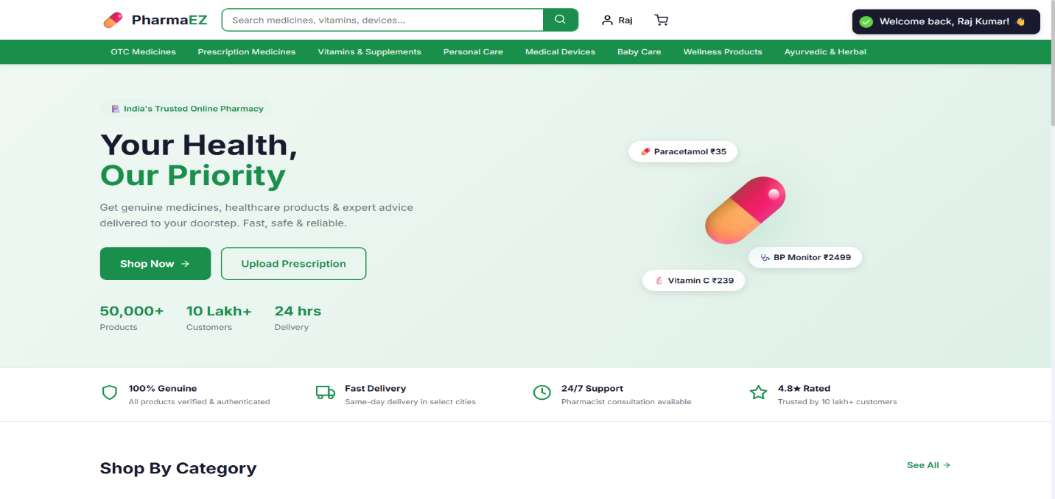

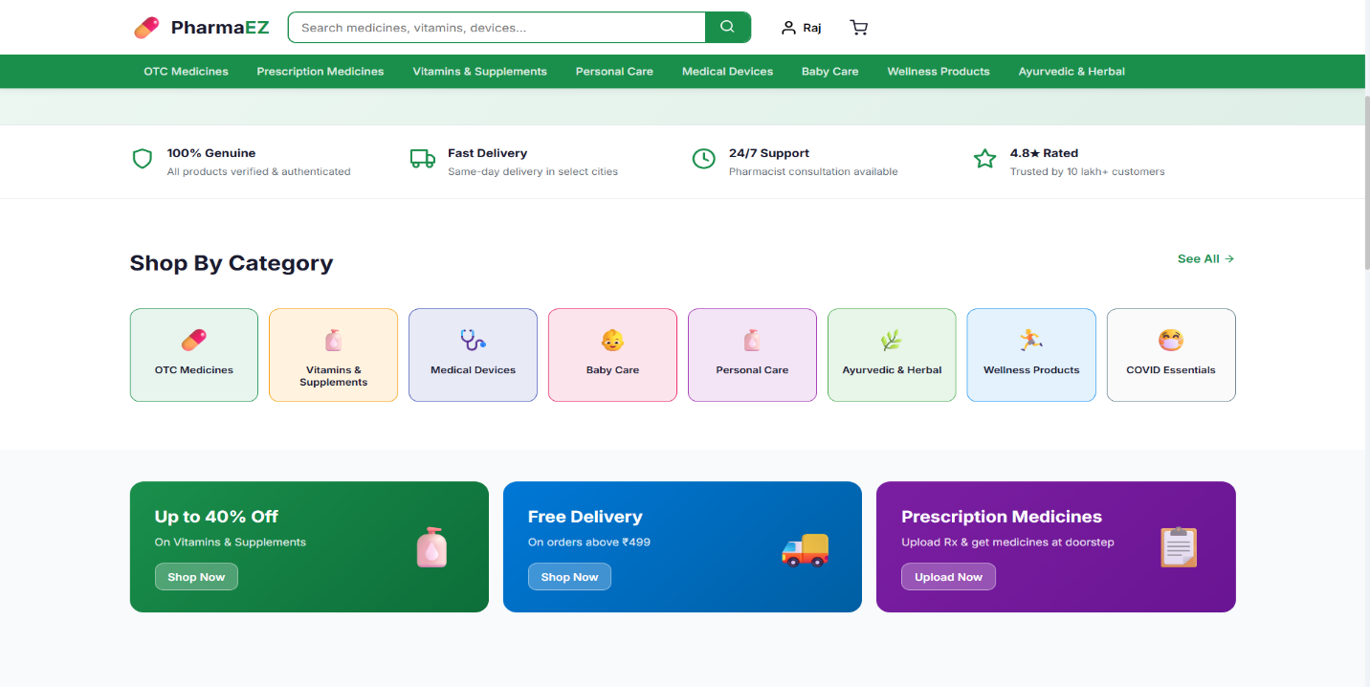
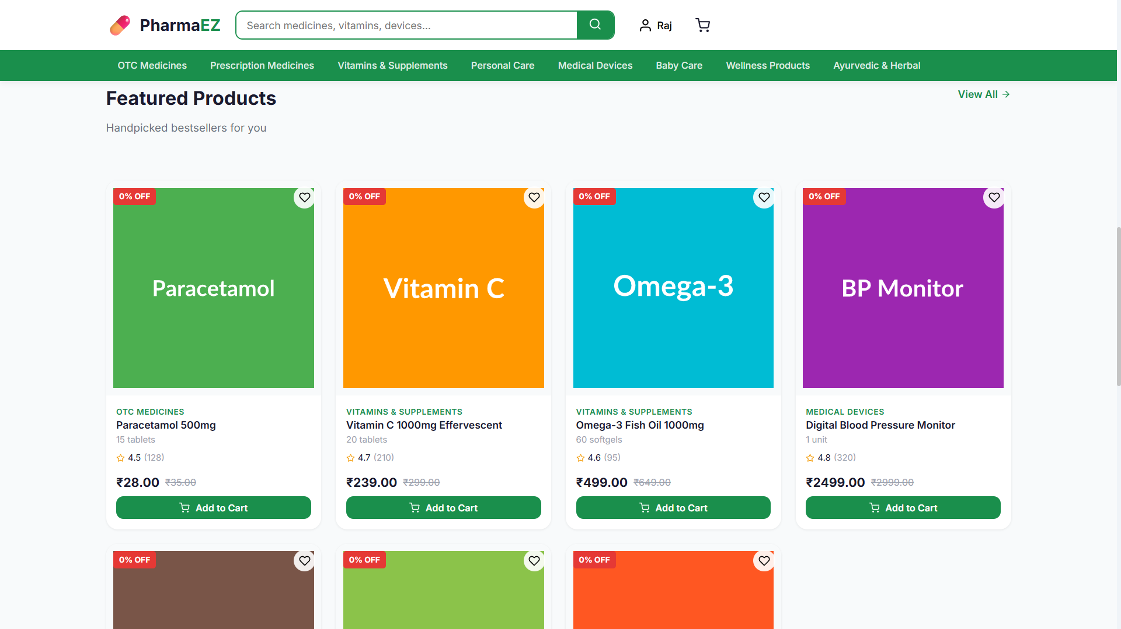

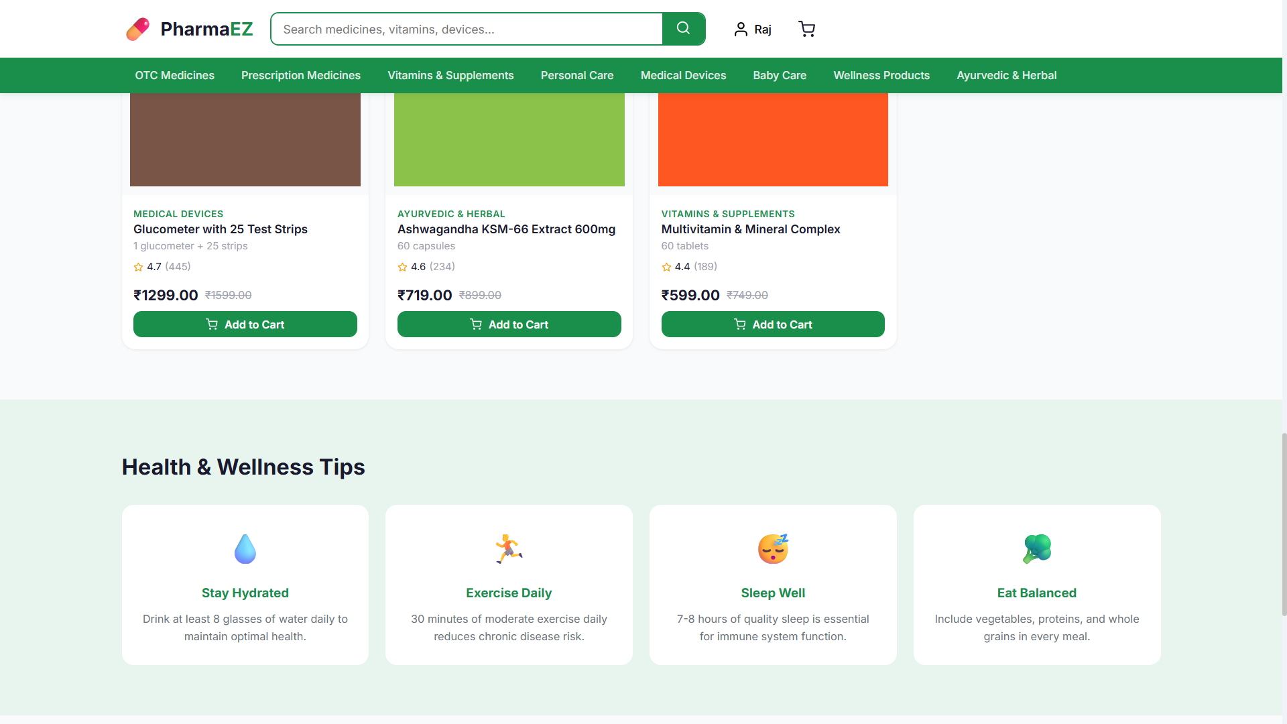

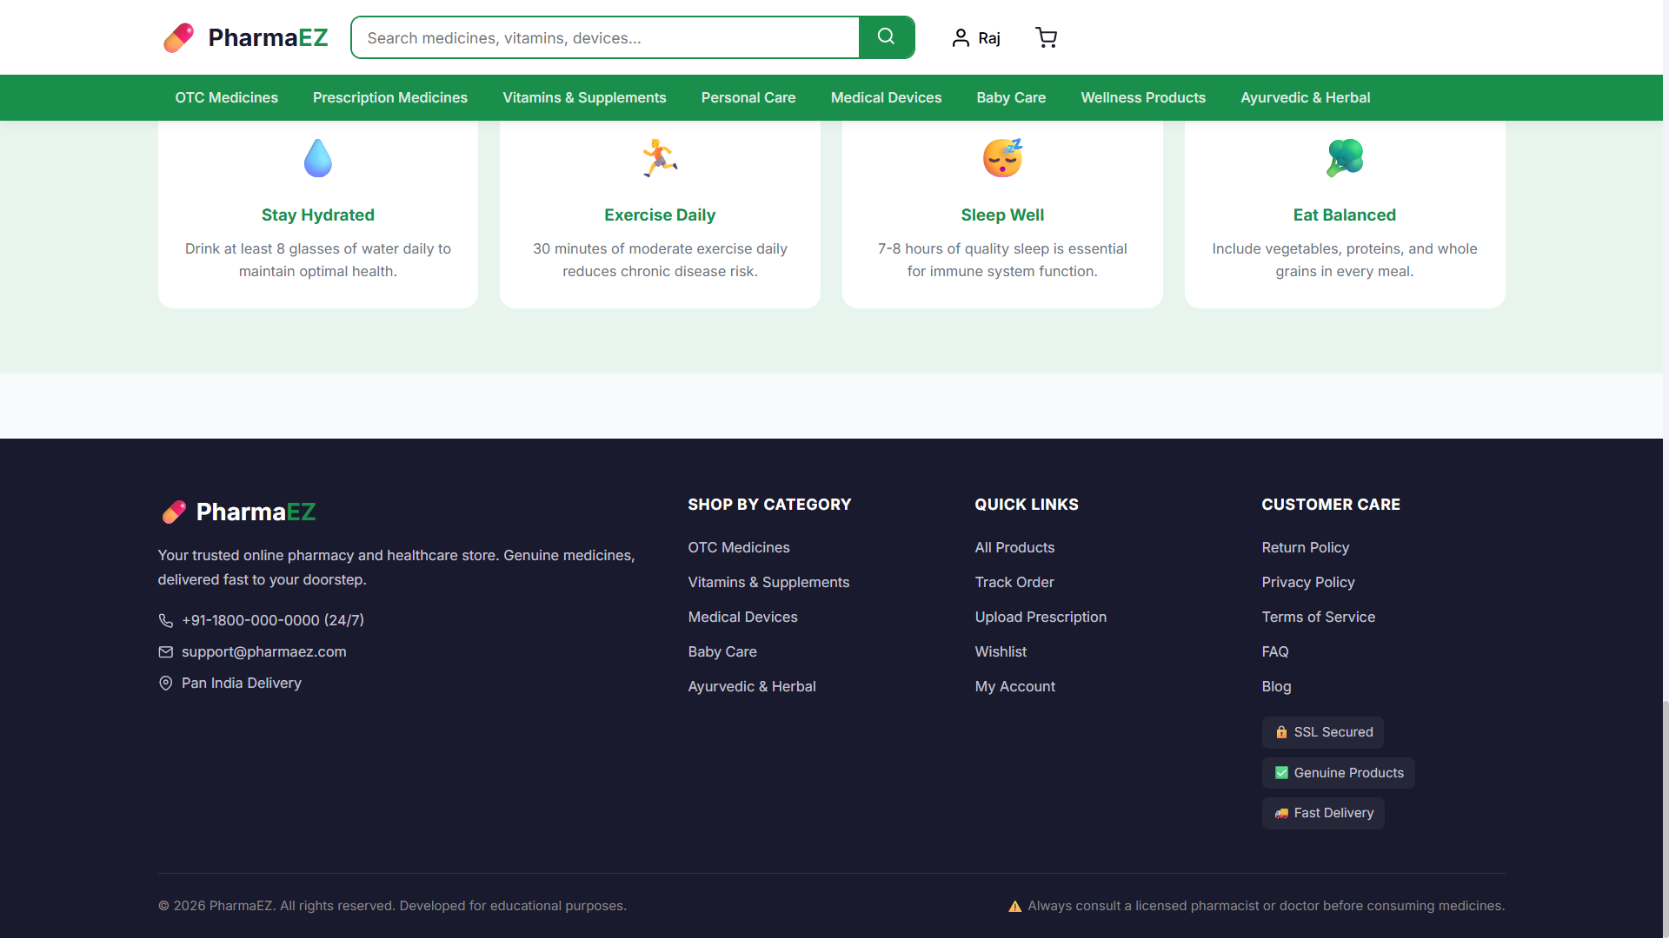

- Products Page: Lists all available healthcare products in a 4-column responsive grid. Sidebar filters for category (10 categories), prescription type (OTC/Rx), and price range. Active filter tags displayed with clear buttons. Sort dropdown for relevance, price, rating, newest.
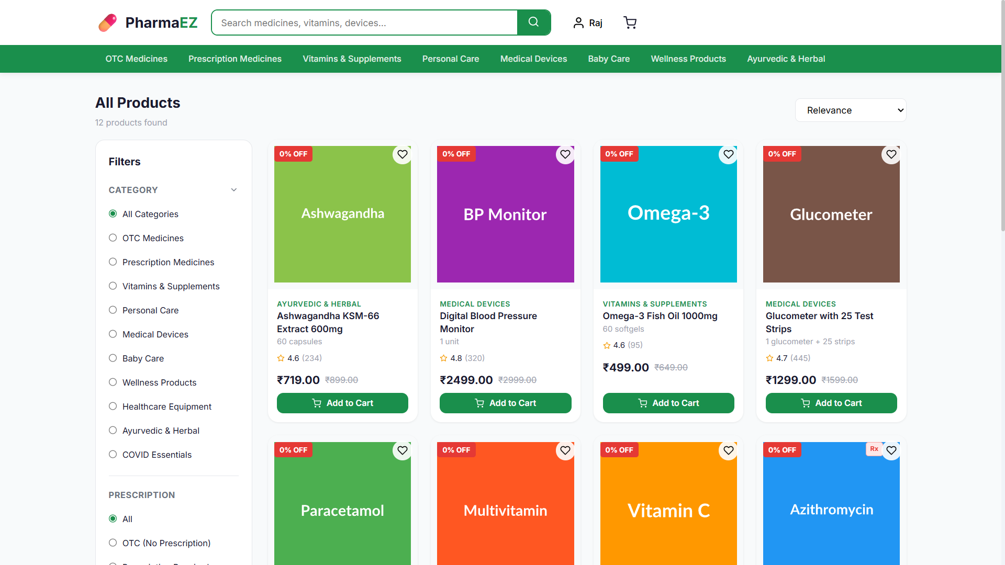

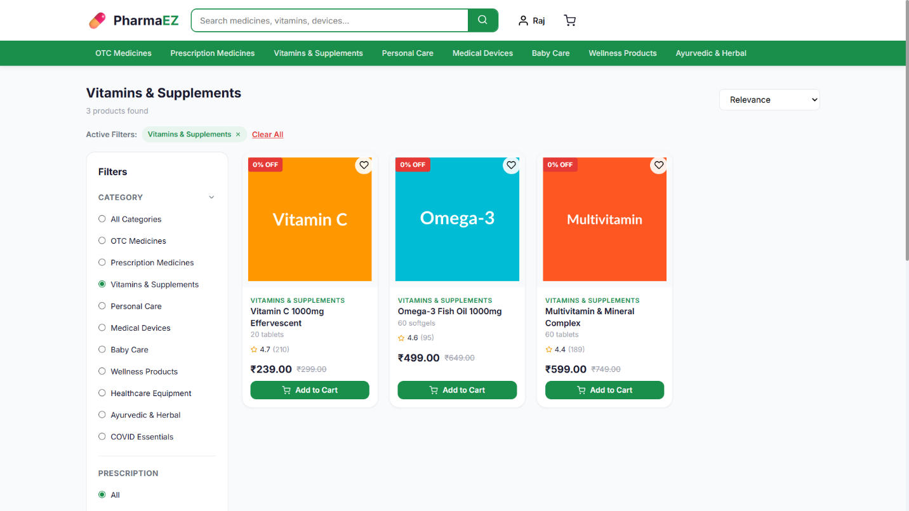

- Product Detail Page: Full product info: image gallery, generic name, salt composition, dosage form, manufacturer, star rating, price with MRP strikethrough, Rx prescription notice (if applicable), quantity selector, Add to Cart / Buy Now / Wishlist buttons, tabbed panels for Description, Usage Instructions, and Customer Reviews. 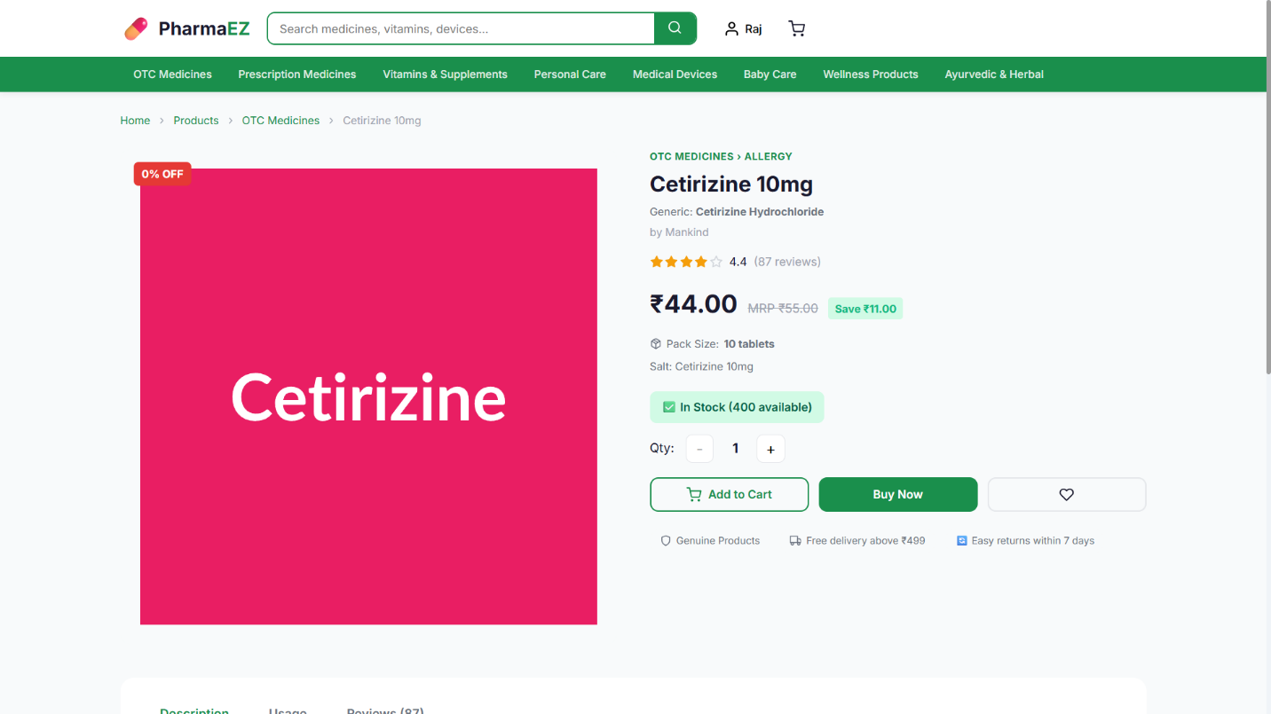

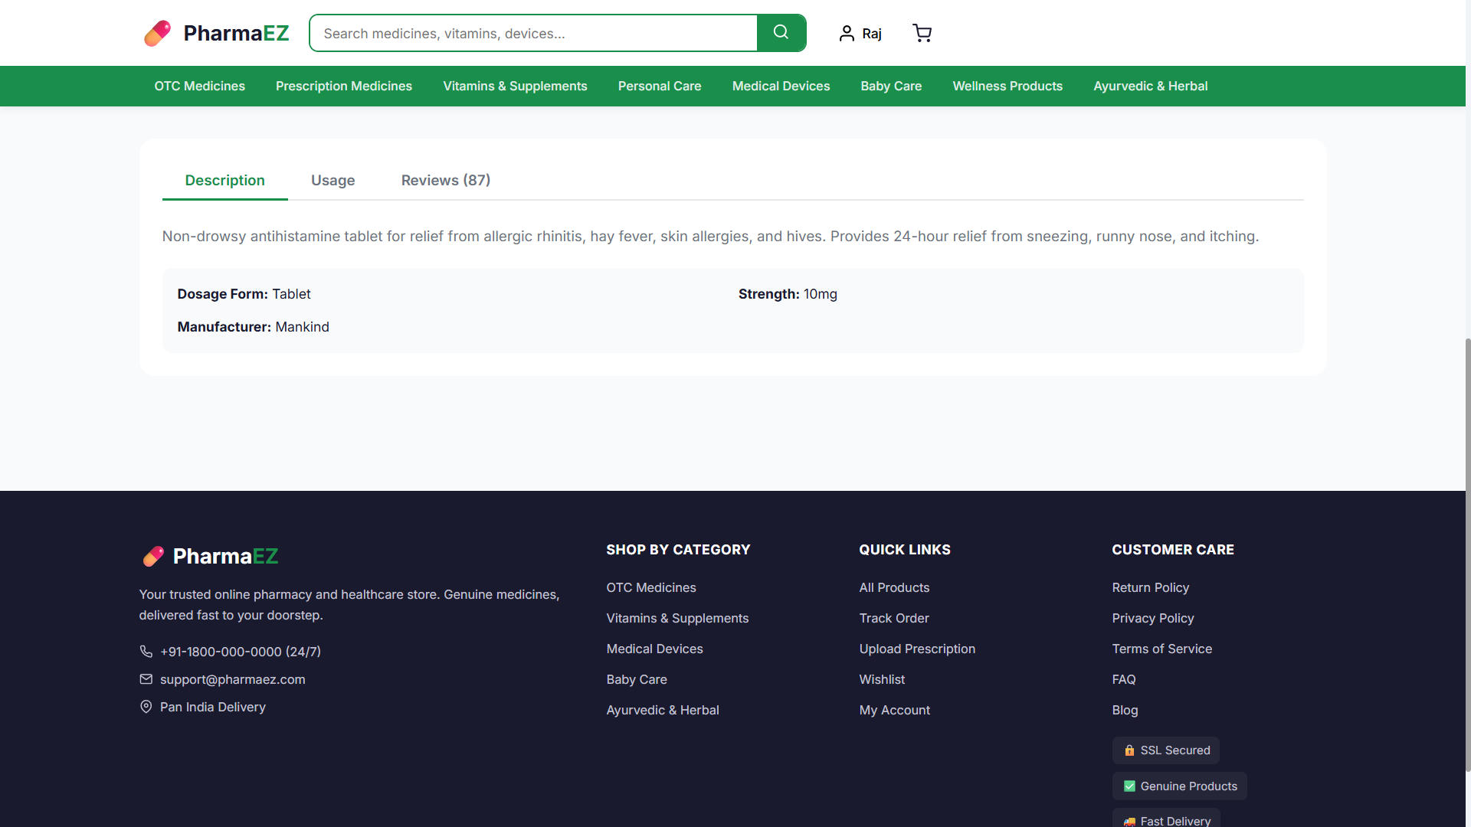

- Authentication Pages: Registration page with name, email, phone, password fields. Login page with email/password. Demo credentials shown for quick testing. 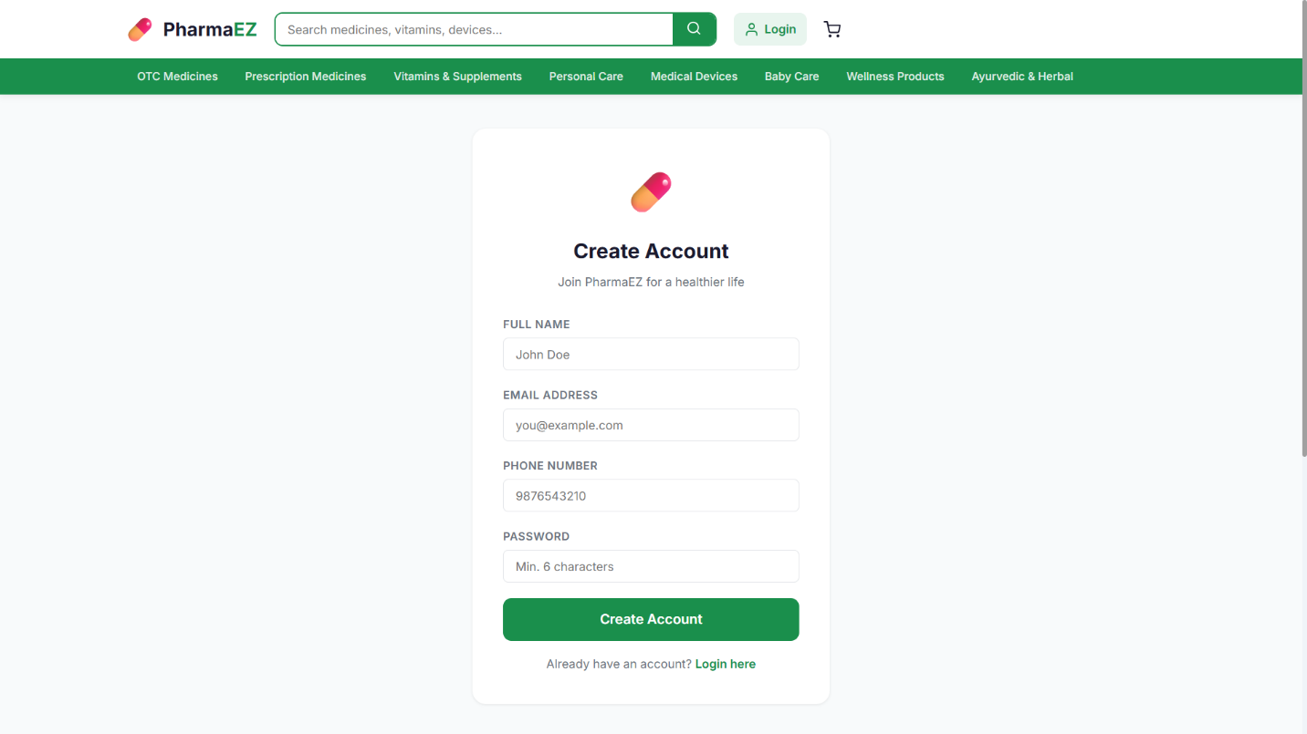

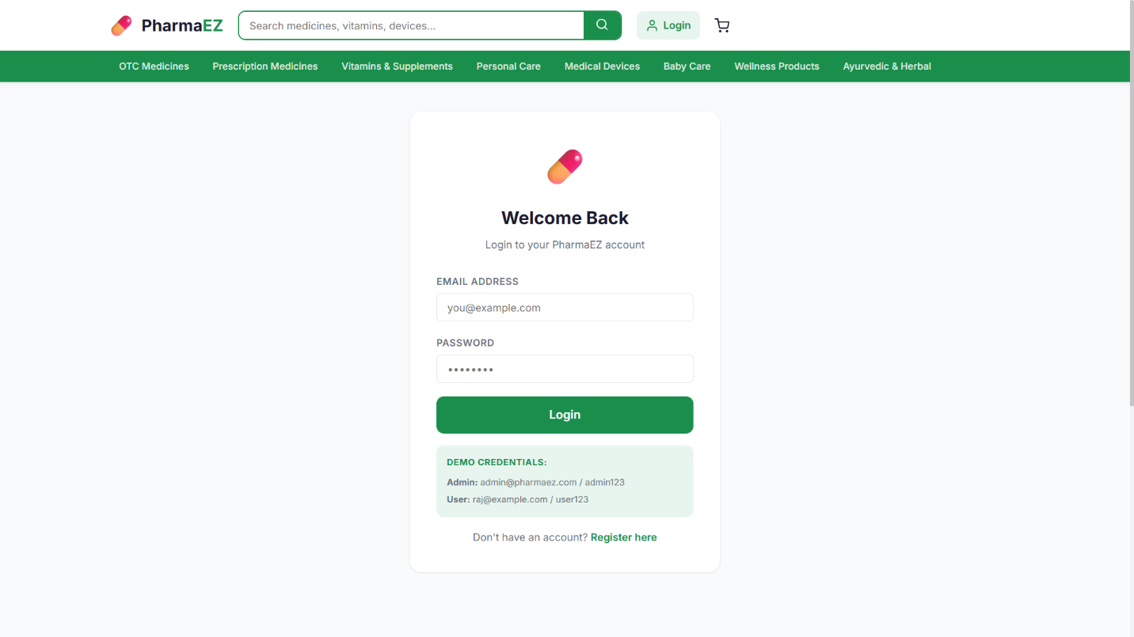

- Cart Page: Manages selected medicines and healthcare products. Shows Rx prescription notice for Rx items, quantity controls, item removal, free shipping progress bar, full price breakdown with GST, and Proceed to Checkout button.
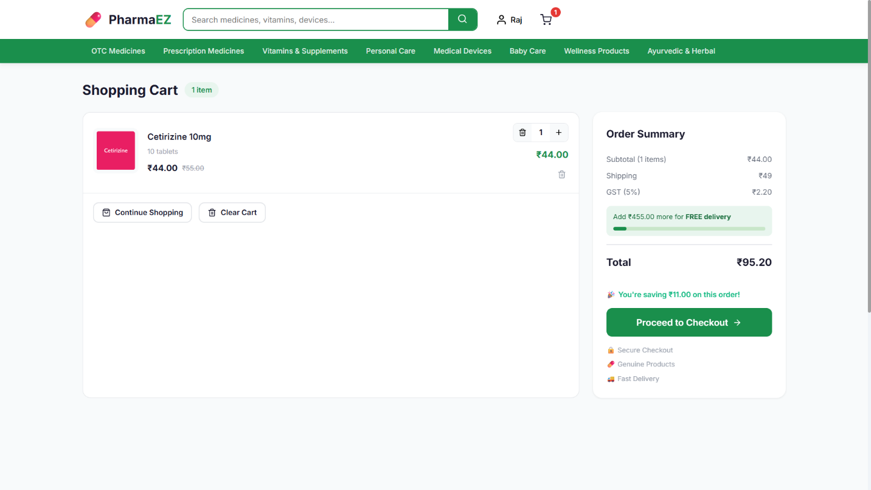

- Checkout Page: 3-step checkout: (1) Address selection from saved addresses or new address form. (2) Payment method (COD/UPI/Card/Net Banking). (3) Complete order review with total before placing. 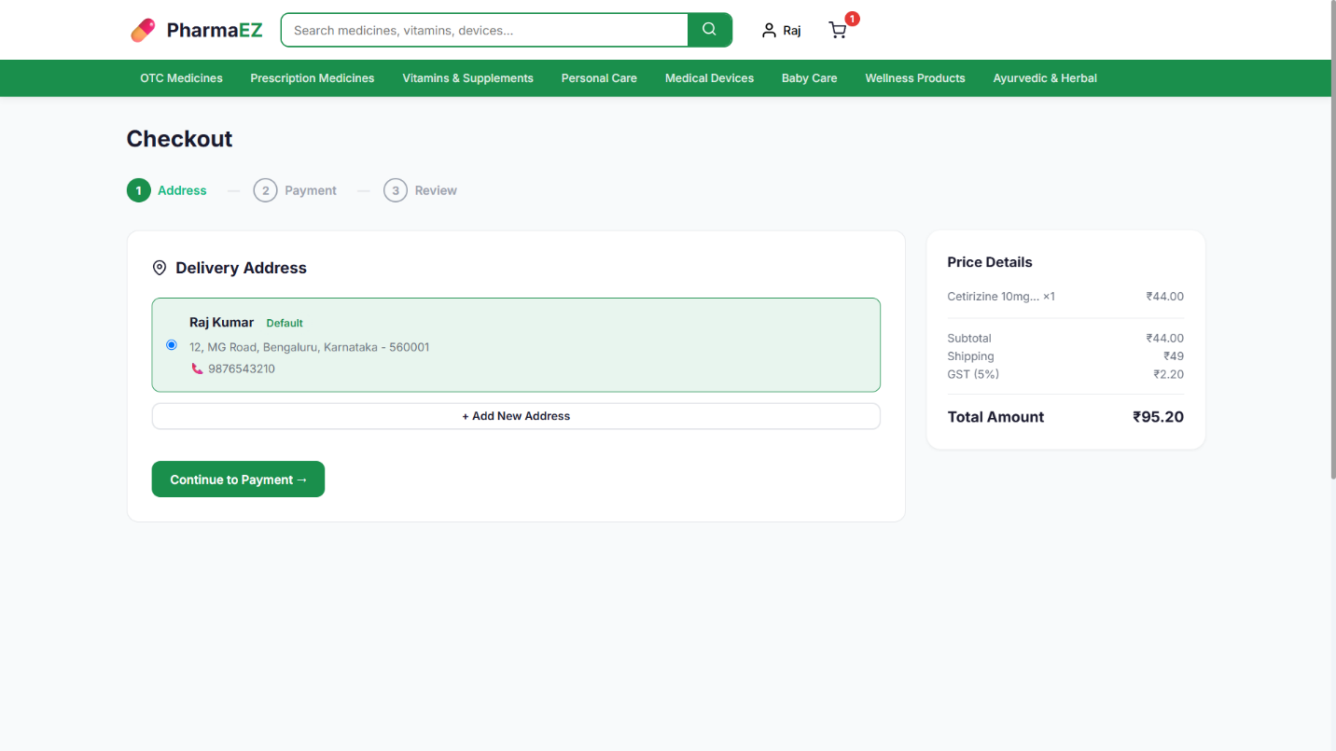

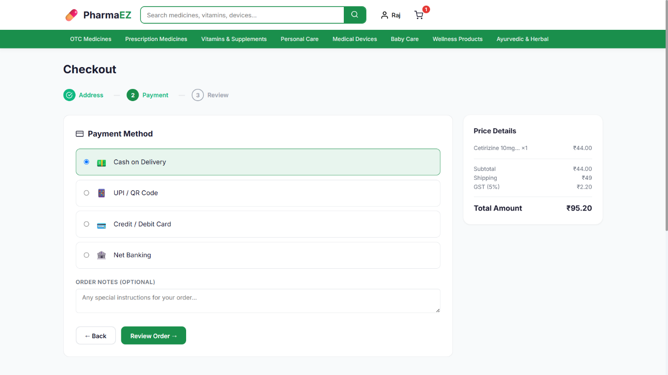

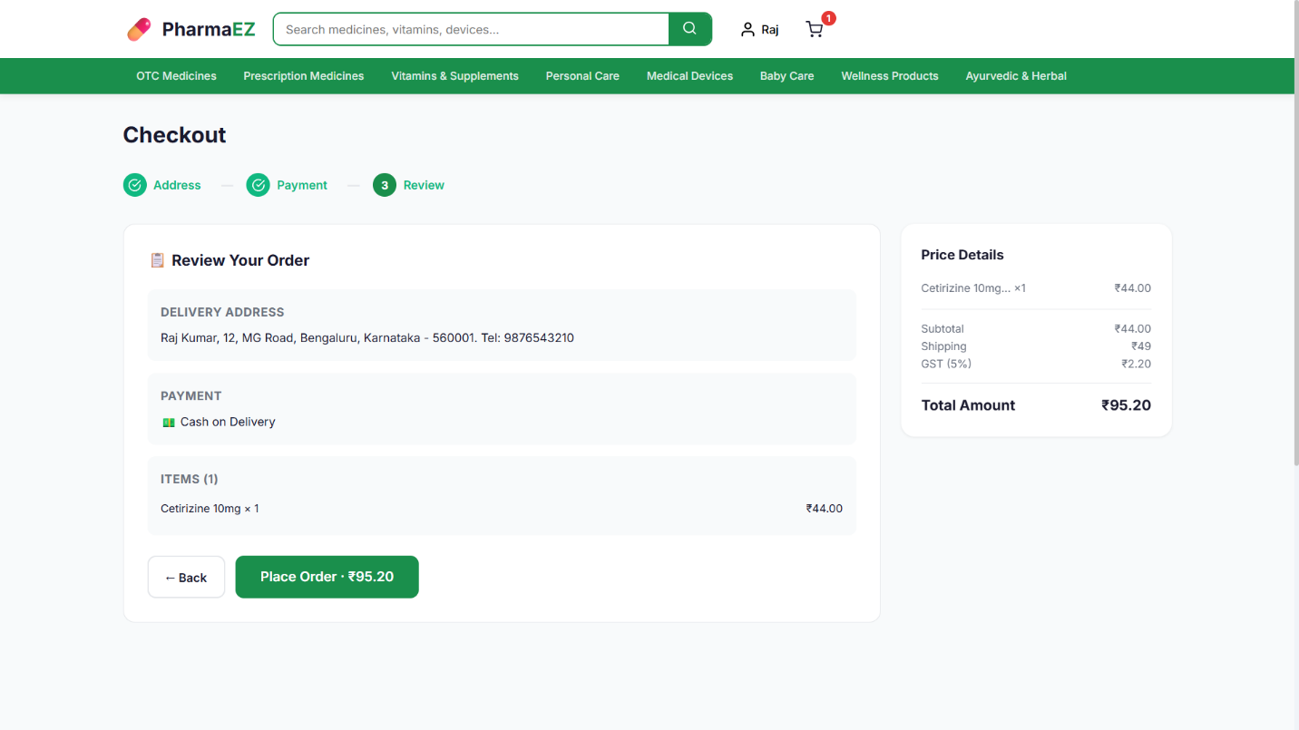

- Order Confirmation Page: Unique order number (PEZ######), estimated delivery date, payment method and status, prescription upload reminder for Rx orders, Track Order and Continue Shopping buttons.
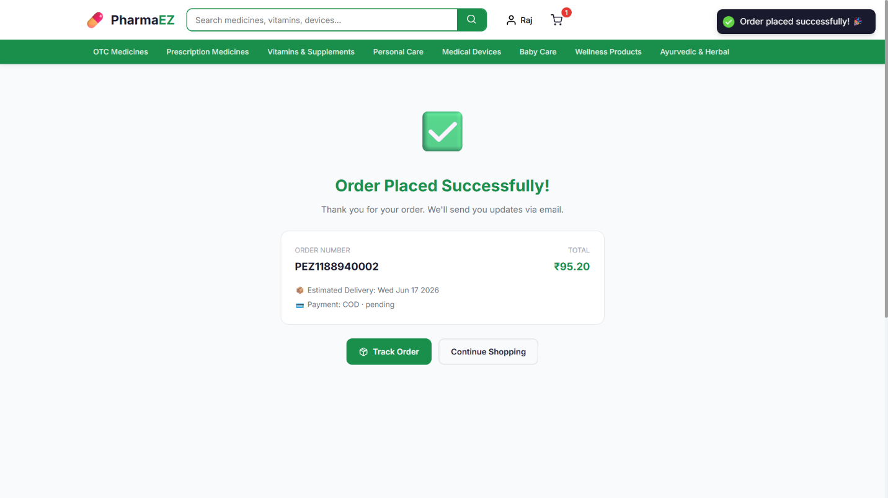

- User Dashboard: Welcome card with name, email, loyalty points badge, and 4 quick-access cards linking to Orders, Wishlist, Prescriptions, and Profile.
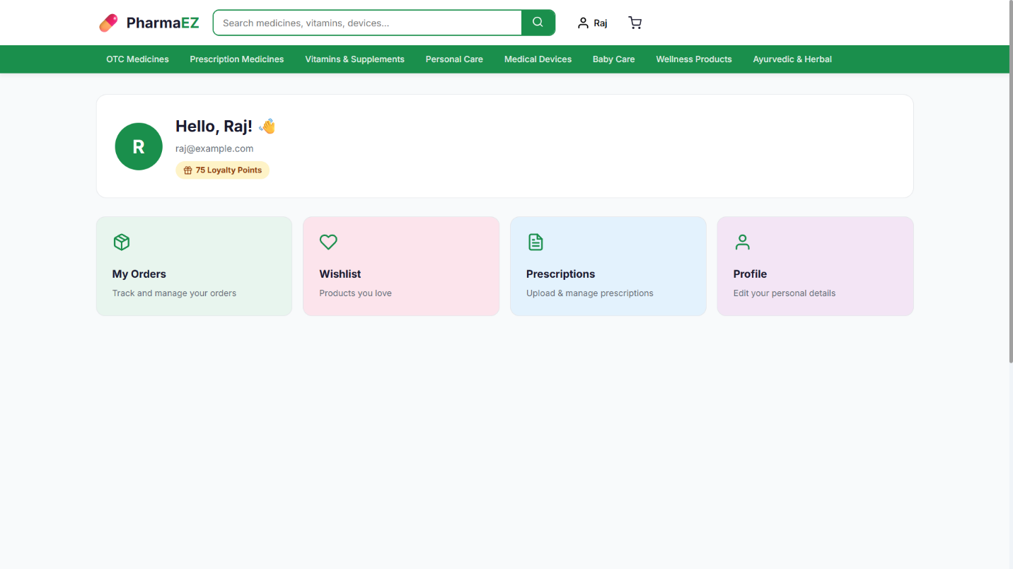

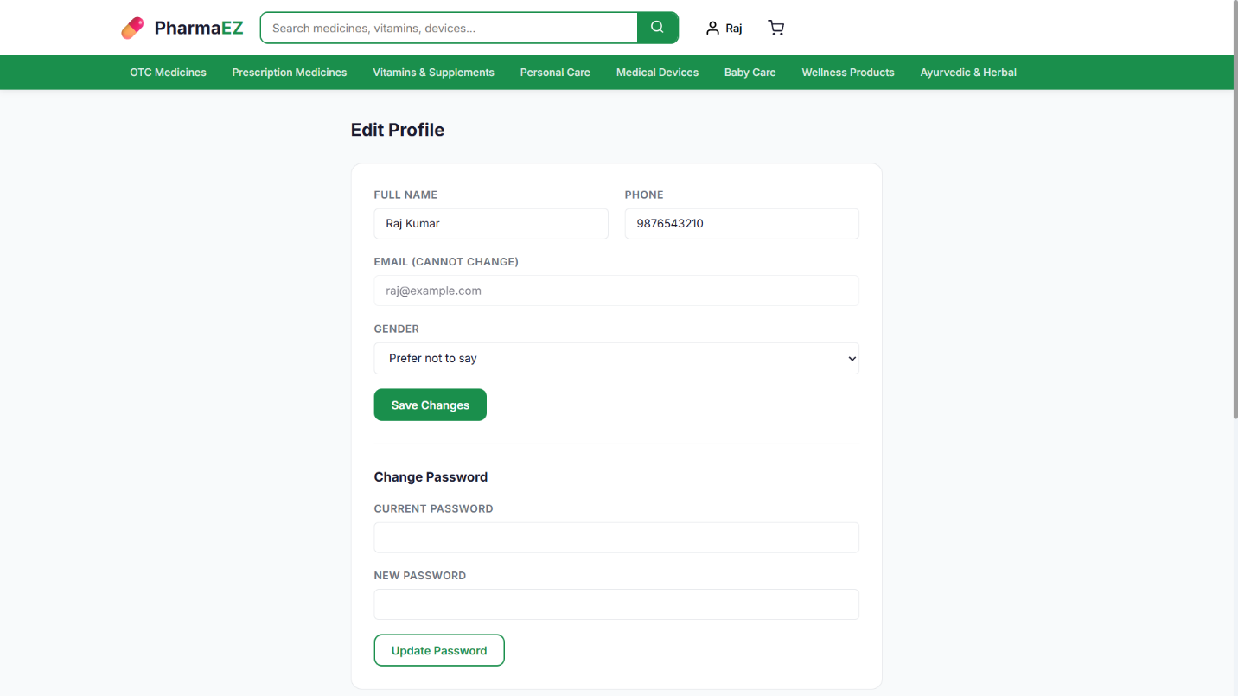

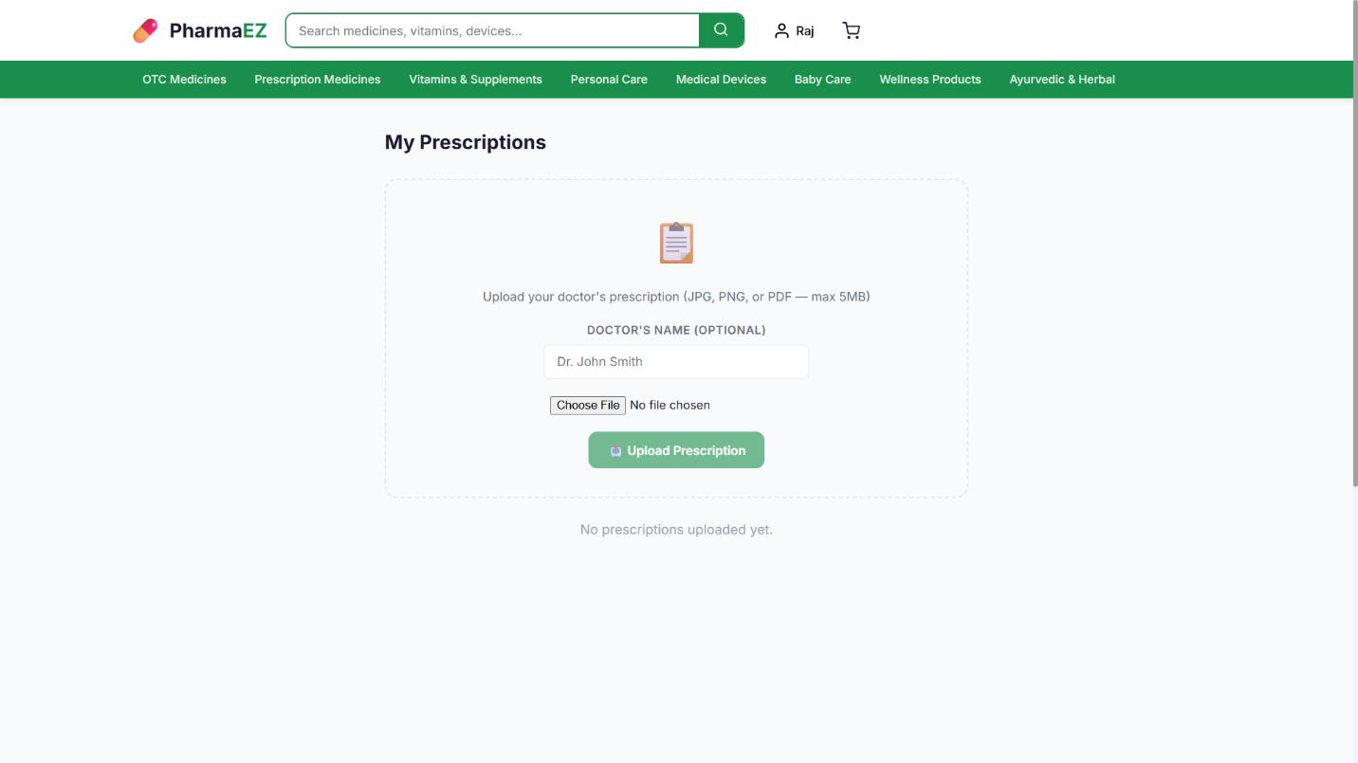

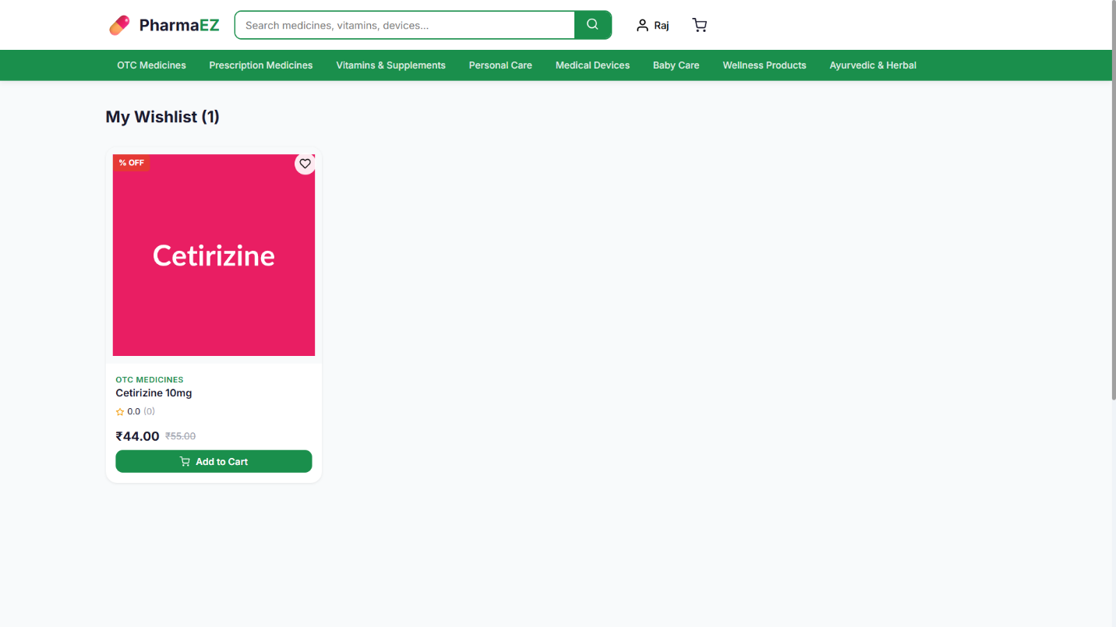

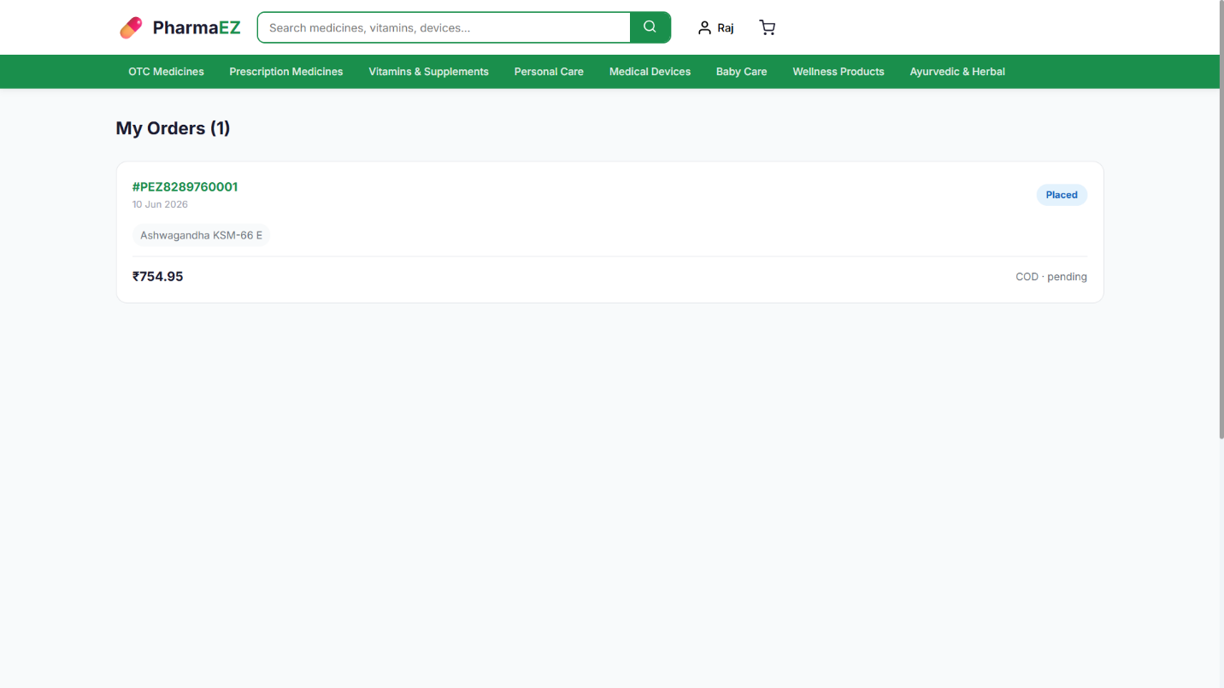

- Order Tracking Page: 5-step visual progress tracker (Placed > Confirmed > Processing > Shipped > Delivered), full item list, delivery address, payment summary, and Cancel Order button.
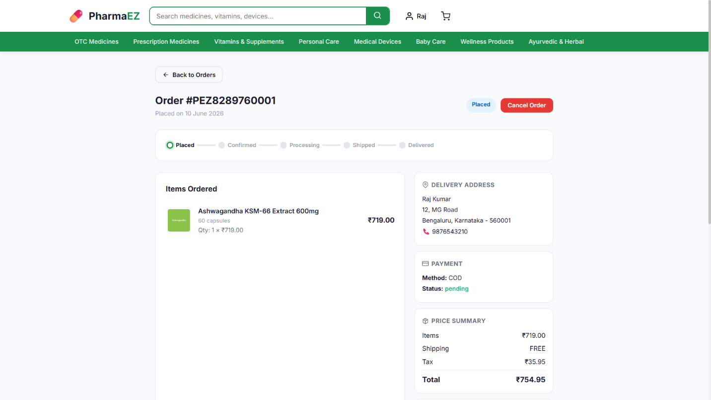

- Prescription Management: Upload form supporting JPG/PNG/PDF files with optional doctor name. Lists all uploaded prescriptions with status badges (pending / approved / rejected). 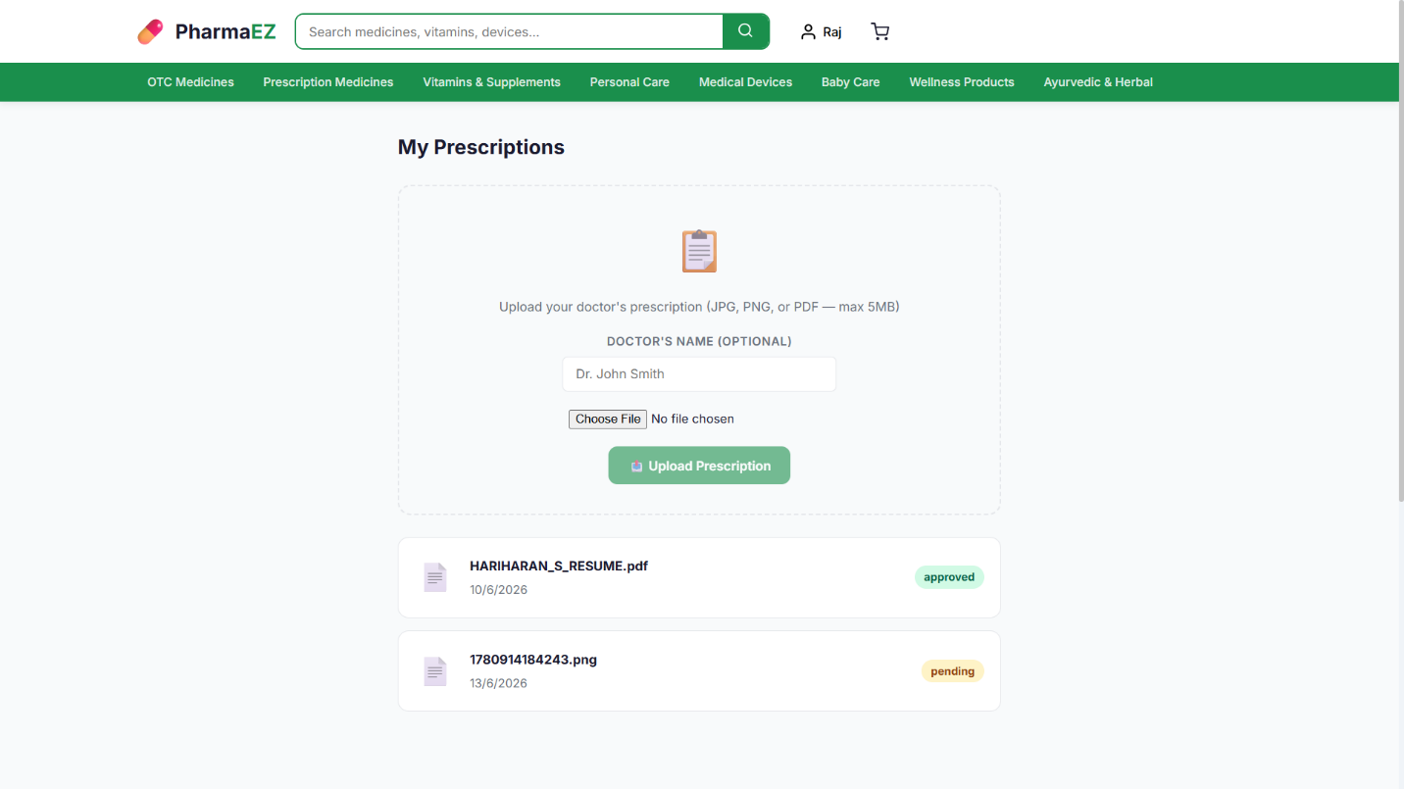

- Admin Dashboard: 4 KPI summary cards (total orders, revenue, users, products), 7-day revenue bar chart, order status breakdown with horizontal bars, recent orders table, and low-stock alert table. 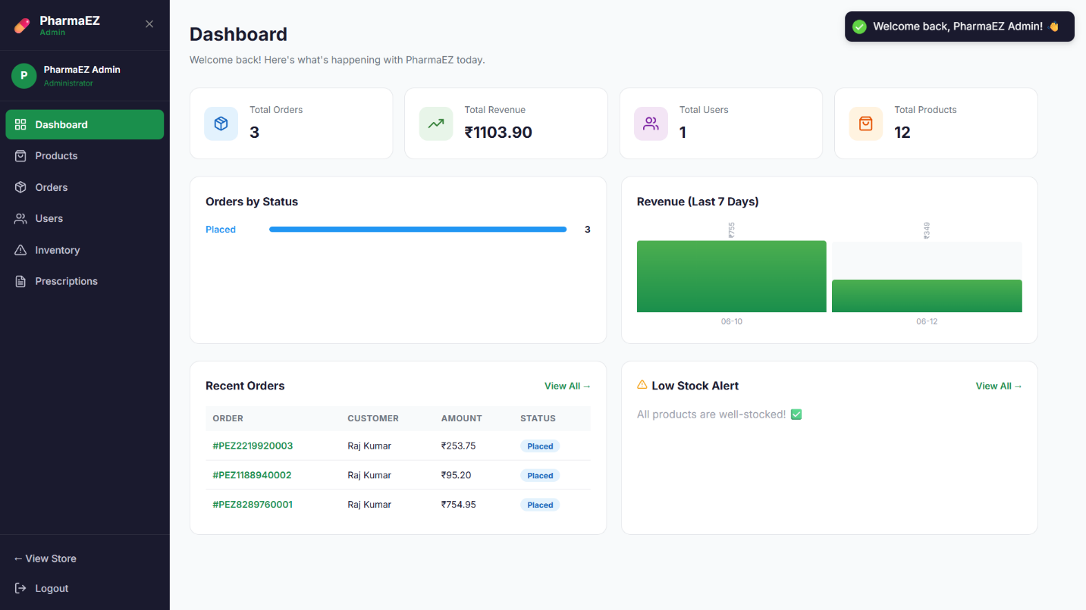
- All Orders (Admin): Filter pills by status, search by order number, inline status dropdown for quick updates, slide-in order detail panel showing items, address, payment, and price summary. 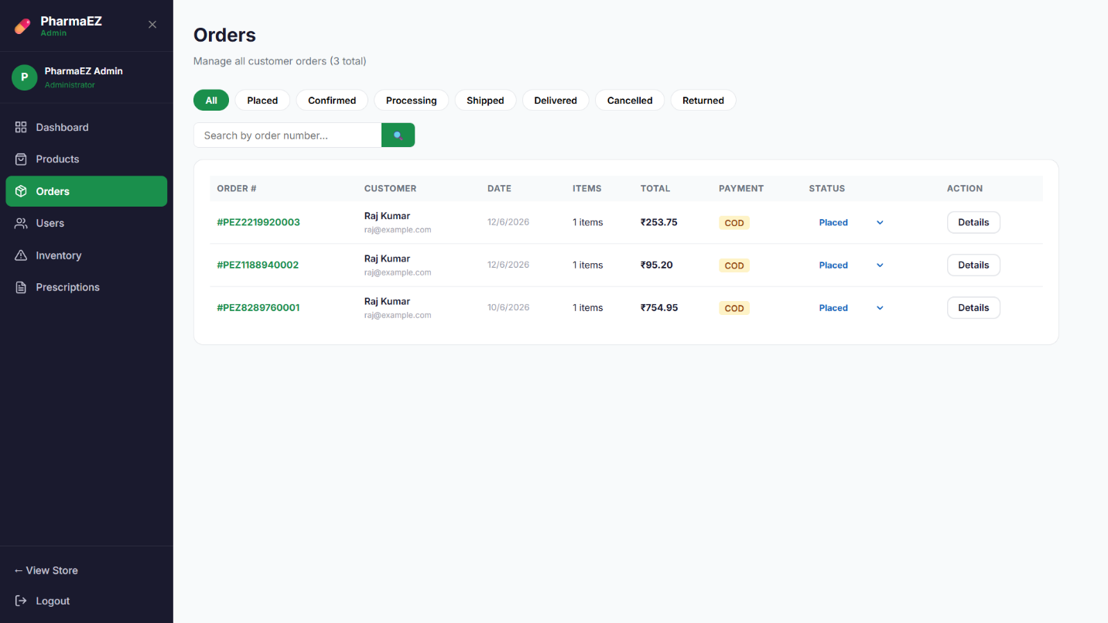

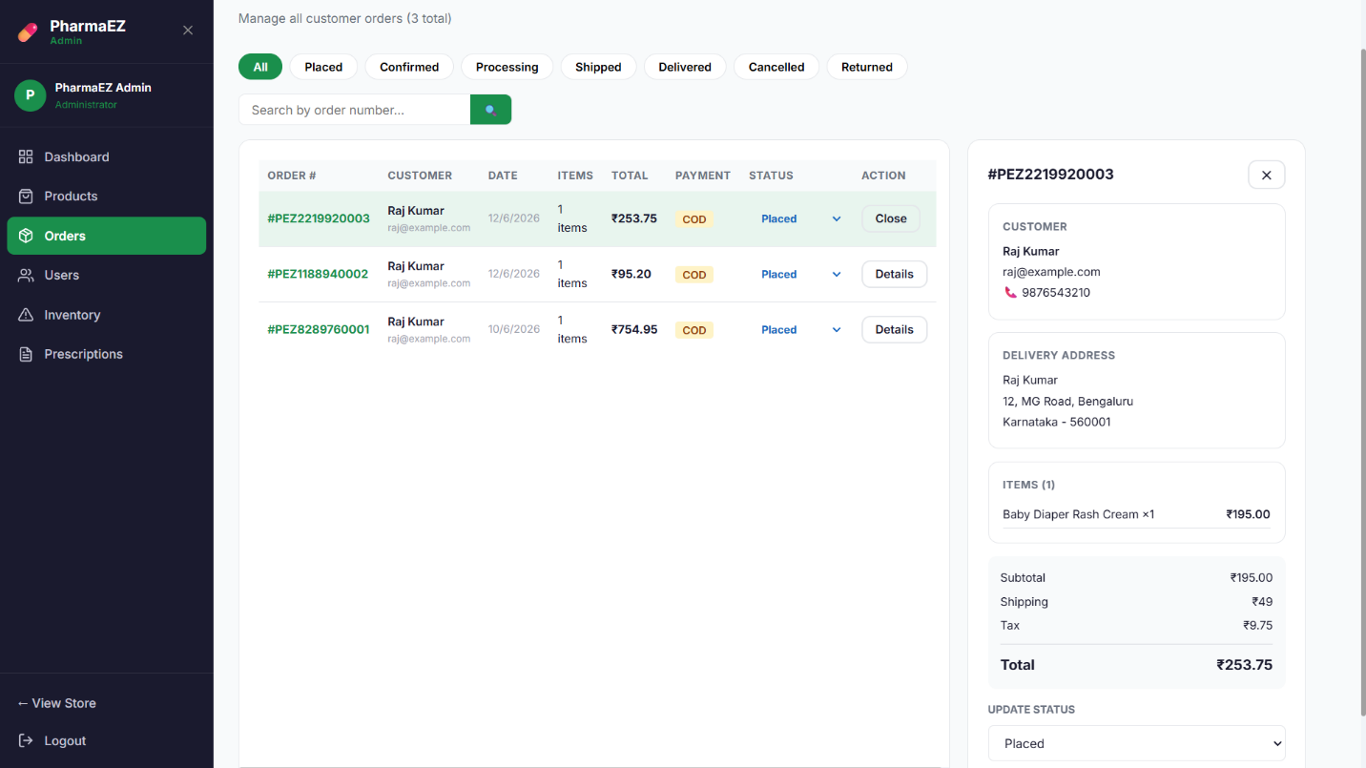

- All Products (Admin): Product table with image thumbnails, category badges, price, stock count (green/amber/red coded), Rx badge, featured flag, and Edit/Delete/View actions. 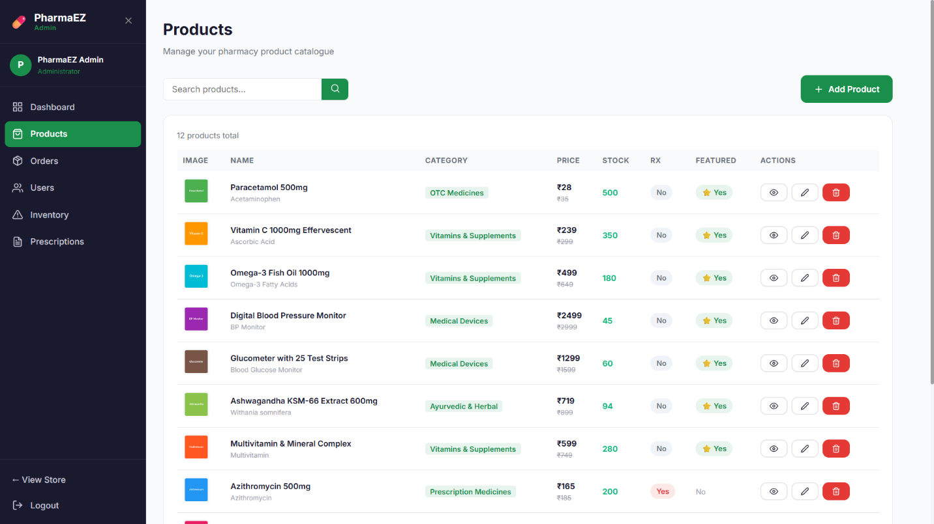

- Add / Edit Product Page (Admin): Comprehensive product form with 4 sections: Basic Information, Pricing & Inventory, Medical Details (salt composition, dosage form, strength, side effects, usage/storage instructions), and Visibility & Tags.
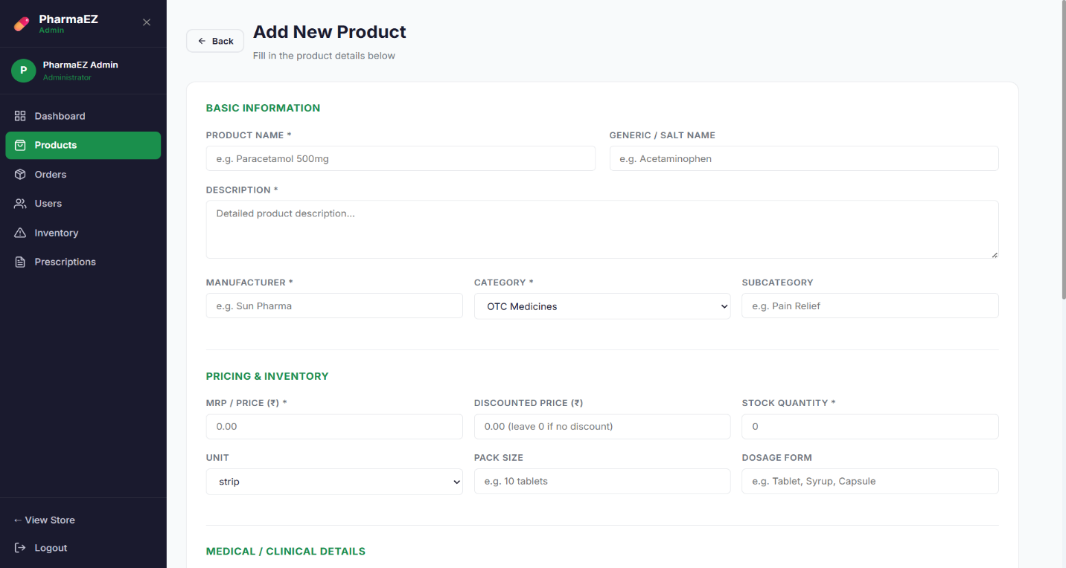

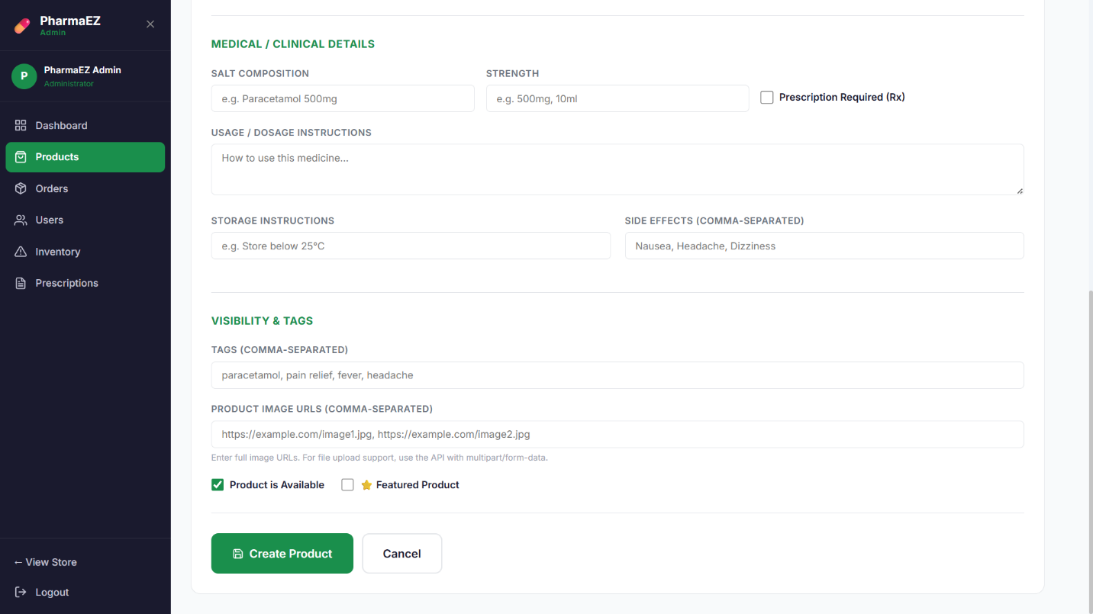

- Inventory Management (Admin): 3 summary cards, stock-by-category table, low-stock alert table with Restock links, and full inventory overview with product images.
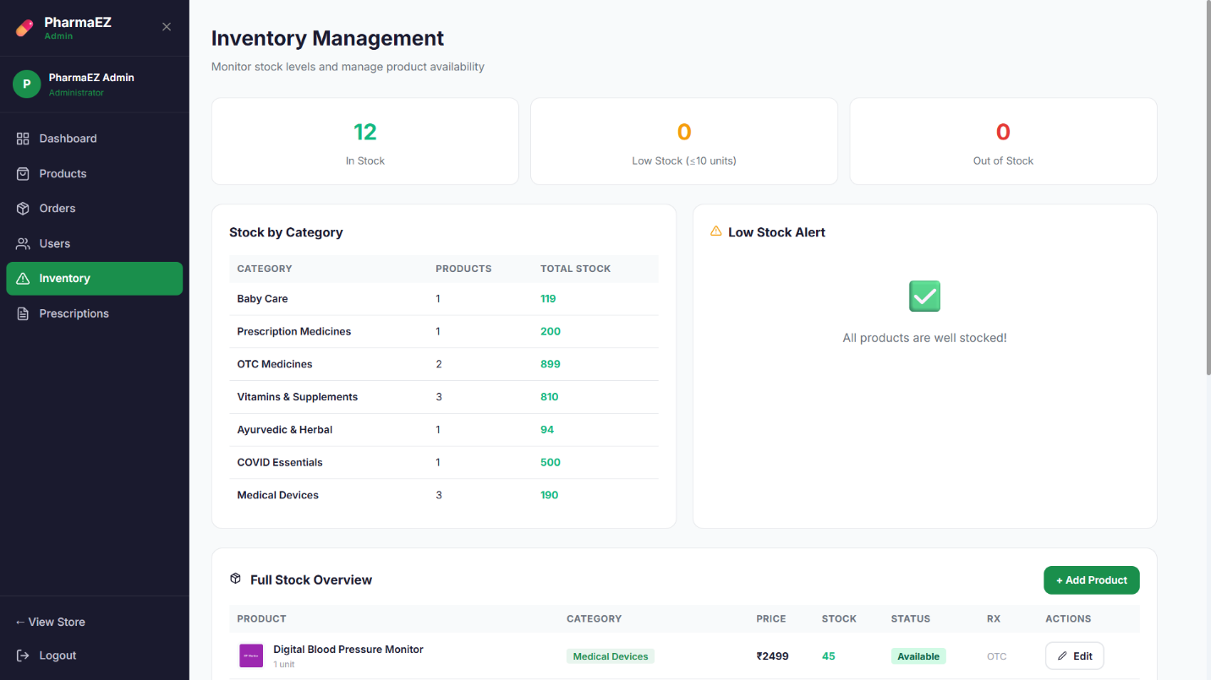

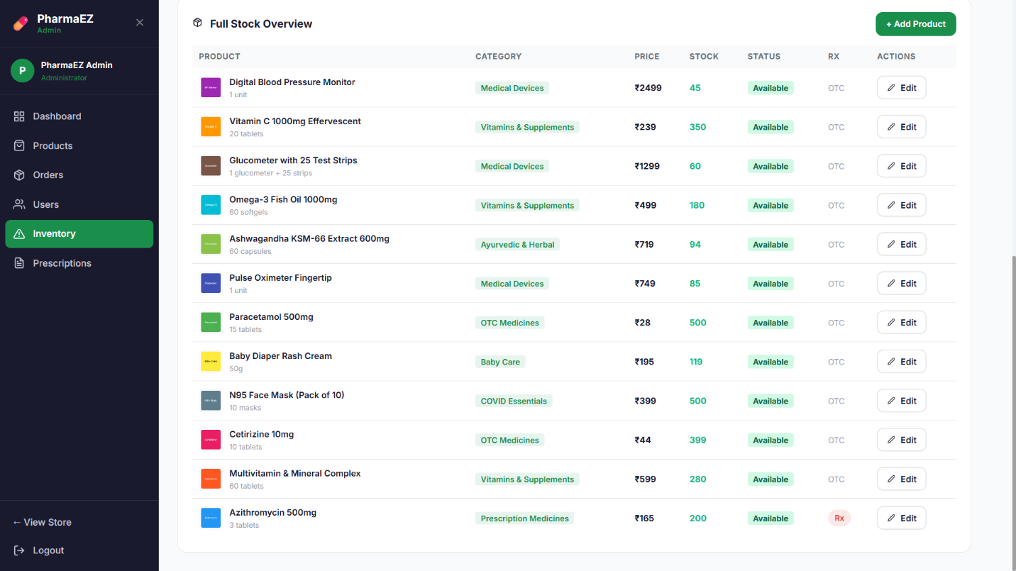

- Prescription Review (Admin): Prescription verification dashboard. Admin views uploaded files (image preview or PDF link), reads patient and doctor details, and Approves or Rejects prescriptions with one click.
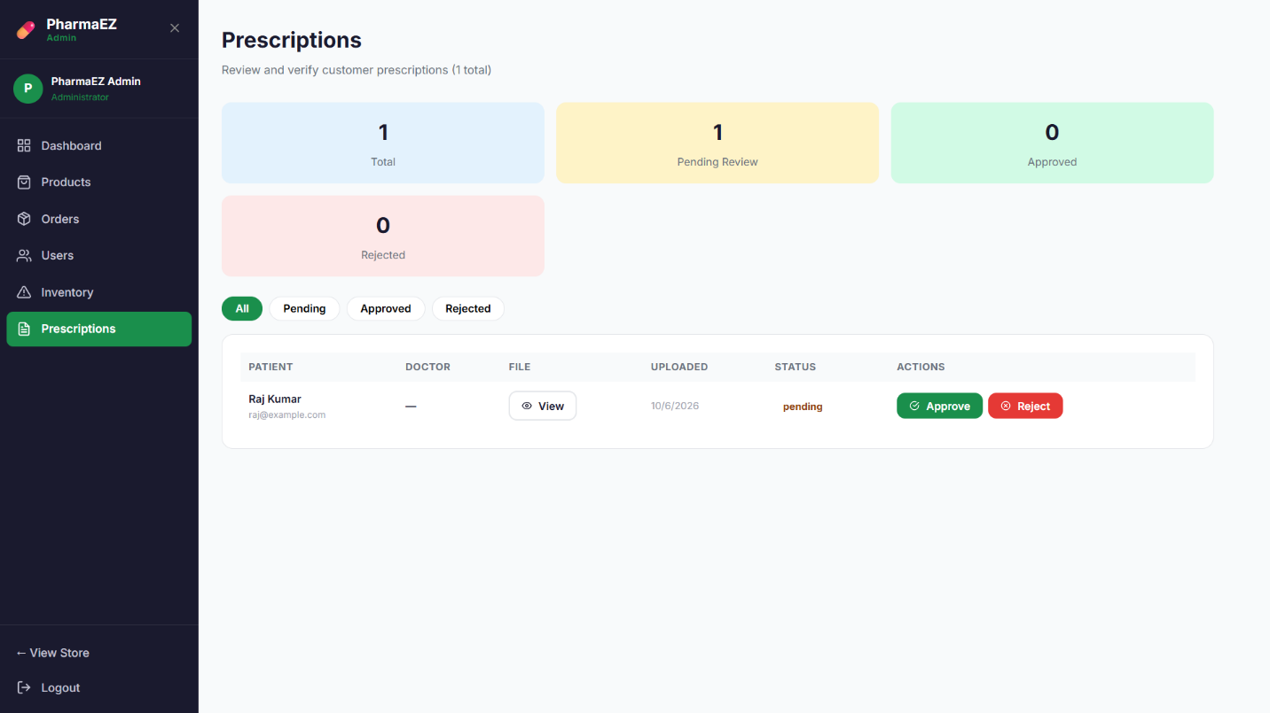

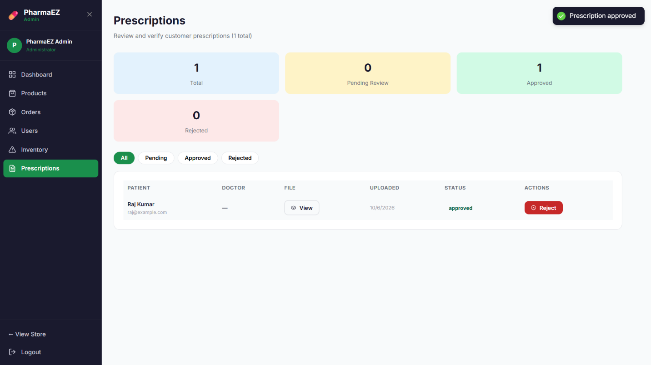

API DOCUMENTATION

Base URL: http://localhost:8000/api

Method | Endpoint | Access | Description
POST | /auth/register | Public | Register new user
POST | /auth/login | Public | Login and receive JWT token
GET | /auth/profile | Private | Get profile + wishlist
PUT | /auth/profile | Private | Update name, phone, gender
PUT | /auth/change-password | Private | Change password
POST | /auth/address | Private | Add delivery address
DELETE | /auth/address/:id | Private | Remove delivery address
POST | /auth/wishlist/:productId | Private | Toggle product in wishlist
POST | /auth/prescription | Private (multipart) | Upload prescription file
GET | /products | Public | List with filters & pagination
GET | /products/featured | Public | Get featured products
GET | /products/category/:cat | Public | Products by category
GET | /products/:id | Public | Single product + reviews
POST | /products/:id/reviews | Private | Add product review
POST | /products | Admin | Create product
PUT | /products/:id | Admin | Update product
DELETE | /products/:id | Admin | Delete product
GET | /cart | Private | Get user cart
POST | /cart | Private | Add item to cart
PUT | /cart/:itemId | Private | Update item quantity
DELETE | /cart/:itemId | Private | Remove cart item
DELETE | /cart | Private | Clear entire cart
POST | /orders | Private | Place order
GET | /orders/my | Private | Get user's orders
GET | /orders/:id | Private | Get order by ID
PUT | /orders/:id/cancel | Private | Cancel order
GET | /orders/admin/stats | Admin | Dashboard statistics
GET | /orders/admin/all | Admin | All orders with filters
PUT | /orders/admin/:id/status | Admin | Update order status
GET | /admin/users | Admin | All users (paginated)
PUT | /admin/users/:id/toggle | Admin | Activate / Deactivate user
GET | /admin/prescriptions | Admin | All uploaded prescriptions
PUT | /admin/prescriptions/:uid/:pid | Admin | Approve / Reject prescription
GET | /admin/config | Public | Store configuration
PUT | /admin/config | Admin | Update store settings
GET | /admin/inventory | Admin | Inventory report
GET | /api/health | Public | Server health check

CONCLUSION

PharmaEZ is a fully-featured, production-ready Pharmacy & Healthcare E-Commerce Web Application built on the MERN stack. It demonstrates the complete lifecycle of a modern web application — from database schema design and RESTful API development to a responsive React frontend with role-based access control.

The platform successfully implements all core e-commerce workflows adapted for the pharmacy domain: prescription upload and pharmacist verification, healthcare-specific product metadata (salt composition, dosage form, strength), inventory management with low-stock alerts, multi-step checkout with Rx compliance checks, a loyalty points reward system, and a comprehensive admin dashboard with analytics.

The application demonstrates key software engineering principles — MVC separation of concerns, JWT-based stateless authentication, Context API for global state, Mongoose schema validation, and a clean modular project structure that is easy to maintain, test, and extend.

Future enhancements could include Razorpay/Stripe payment gateway integration, real-time notifications via Socket.io, a React Native mobile app, AI-powered medicine interaction checker, and a doctor consultation booking module.

PharmaEZ — Your Health, Our Priority 💊
Built with MongoDB · Express.js · React.js · Node.js

